SEVEN WONDERS OF THE WORLD

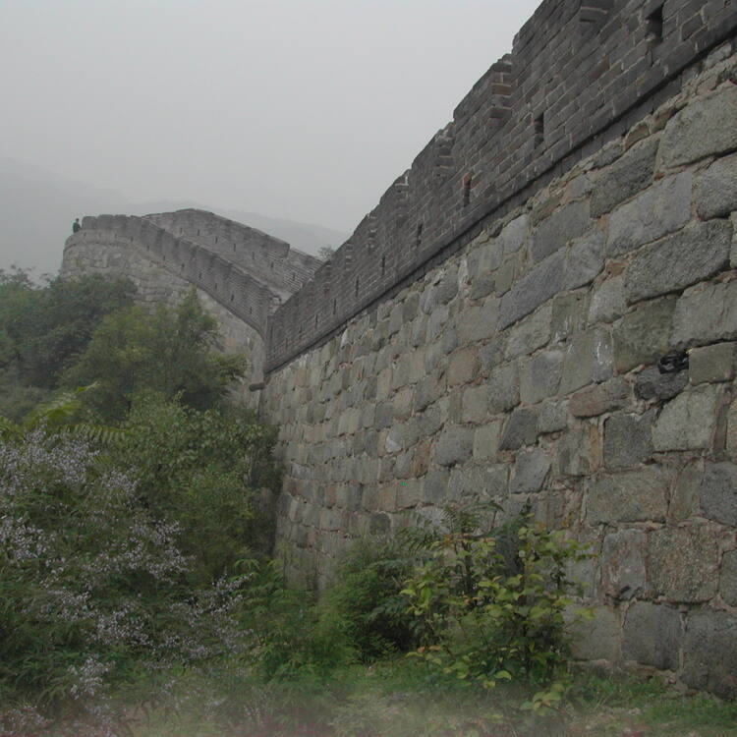**1)The Great Wall**

In c. 220 B.C., under Qin Shi Huang, sections of earlier fortifications were joined together to form a united defense system against invasions from the north. Construction continued up to the Ming dynasty (1368–1644), when the Great Wall became the world's largest military structure. Its historic and strategic importance is matched only by its architectural significance.

The Great Wall was continuously built from the 3rd century BC to the 17th century AD on the northern border of the country as the great military defense project of successive Chinese Empires, with a total length of more than 20,000 kilometers. The Great Wall begins in the east at in Hebei province and ends at Gansu province to the west. Its main body consists of walls, horse tracks, watch towers, and shelters on the wall, and includes fortresses and passes along the wall The Great Wall reflects collision and exchanges between agricultural civilizations and nomadic civilizations in ancient China. It provides significant physical evidence of the far-sighted political strategic thinking and mighty military and national defense forces of central empires in ancient China, and is an outstanding example of the superb military architecture, technology and art of ancient China. It embodies unparalleled significance as the national symbol for safeguarding the security of the country and its people.

**2)Petra Jordan**

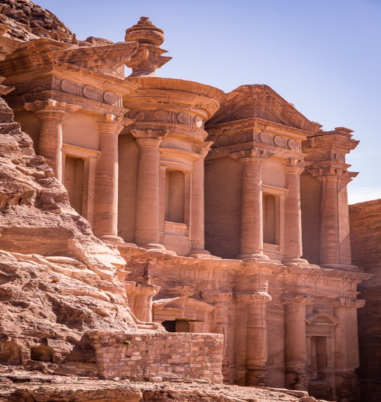

Carved directly into vibrant red, white, pink, and sandstone cliff faces, the prehistoric Jordanian city of Petra was "lost" to the Western world for hundreds of years.

Located amid rugged desert canyons and mountains in what is now the southwestern corner of the Hashemite Kingdom of Jordan, Petra was once a thriving trading center and the capital of the Nabataean empire between 400 B.C. and A.D. 106.

The city sat empty and in near ruin for centuries. Only in the early 1800s did a European traveler disguise himself in Bedouin costume and infiltrate the mysterious locale.

In 1985, the Petra Archaeological Park was [declared a UNESCO World Heritage site](http://whc.unesco.org/en/list/326), and in 2007 it was named one of the new seven wonders of the world.

3) **Christ The Redeemer**

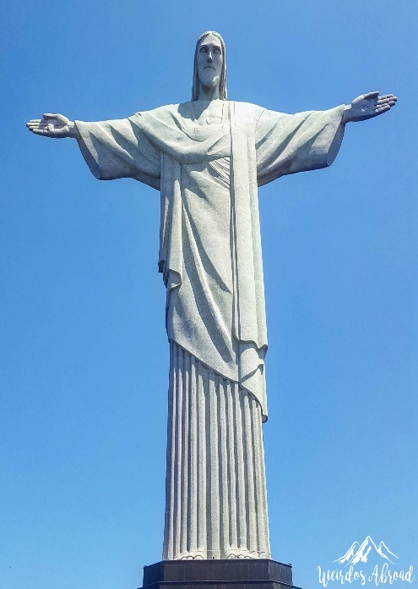

Christ the Redeemer is an Art Deco statue of Jesus Christ overlooking the Brazilian city of Rio de Janeiro.

## History of Christ the Redeemer

Christ the Redeemer (Cristo Redentor) is a 30 metre high statue, mounted upon an 8 metre pedestal, and of course the 700 metre high mountain of Corcovado. It was constructed between 1922 and 1931 from soapstone and reinforced concrete. Today it is a Brazilian cultural icon and global symbol of Christianity.

An earlier proposal for a Christian monument on Mount Corcovada was dismissed after the country became a republic in 1889, when the roles of church and state were separated. However a second proposal came in 1920 from Catholics motivated by the perceived atheism of contemporary Rio de Janeiro.

The proposal attracted donations to support the construction, which came largely from Brazilian Catholics. Designs included a representation of the Christian cross, a statue of Jesus holding a globe in his hands and a pedestal that symbolised the world. The resultant Christ the Redeemer statue symbolises peace.

Christ the Redeemer was created by French sculptor Paul Landwoski and Brazilian engineer Heitor da Silva Costa, working with French engineer Albert Caquot. It weighs 635 metric tons. The face of the Christ the Redeemer statue was created by Gheorghe Leonida, a Romanian sculptor living in [Paris](https://www.historyhit.com/guides/the-top-10-historic-sites-of-paris/) hired by Landowski.

On the 75th anniversary of the statue’s construction, in October 2006, the Archbishop of Rio consecrated a chapel beneath the statue. The statue was hit by lightning in 2008 and in 2014, causing damage, while it has also been the focus of recent renovation efforts.

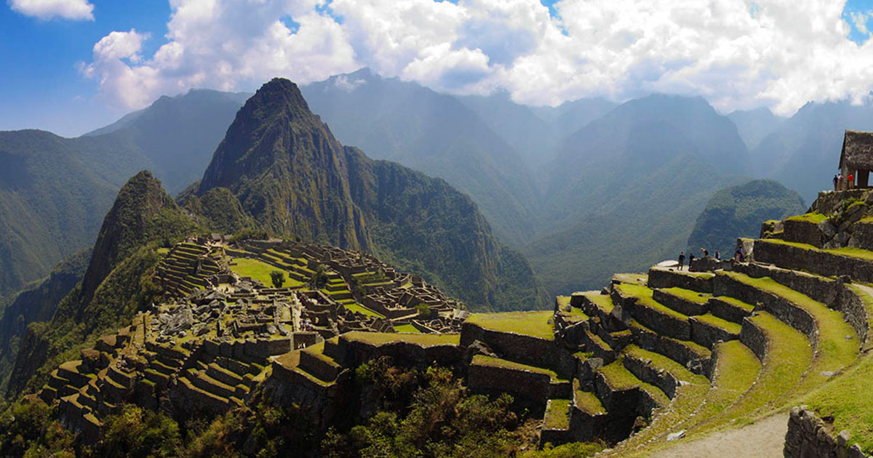4) Machu Picchu - Peru.

The dwellings at Machu Picchu were probably built and occupied from the mid-15th to the early or mid-16th century. Machu Picchu’s construction style and other evidence suggest that it was a palace complex of the ruler Pachacuti inca (reigned *c.* 1438–71). Several dozen skeletons were excavated there in 1912, and, because most of those were initially identified as female, Bingham suggested that Machu Picchu was a sanctuary for the Virgins of the Sun (the [Chosen Women](https://www.britannica.com/topic/Chosen-Women)), an elite Inca group. Technology at the turn of the 21st-century, however, identified a significant proportion of males and a great [diversity](https://www.merriam-webster.com/dictionary/diversity) in physical types. Both skeletal and material remains now suggest to scholars that Machu Picchu served as a royal retreat. The reason for the site’s abandonment is also unknown, but lack of water may have been a factor.

The high level of preservation and the general layout of the ruin are remarkable. Its southern, eastern, and western portions are surrounded by dozens of stepped agricultural terraces formerly watered by an aqueduct system. Some of those terraces were still being used by local Indians when Bingham arrived in 1911. Walkways and thousands of steps, consisting of stone blocks as well as footholds carved into [underlying](https://www.britannica.com/dictionary/underlying) rock, connect the plazas, the residential areas, the terraces, the cemetery, and the major buildings. The Main Plaza, partly divided by wide terraces, is at the north-central end of the site. At the southeastern end is the only formal entrance, which leads to the Inca Trail.

# 5) Chichen-Itza

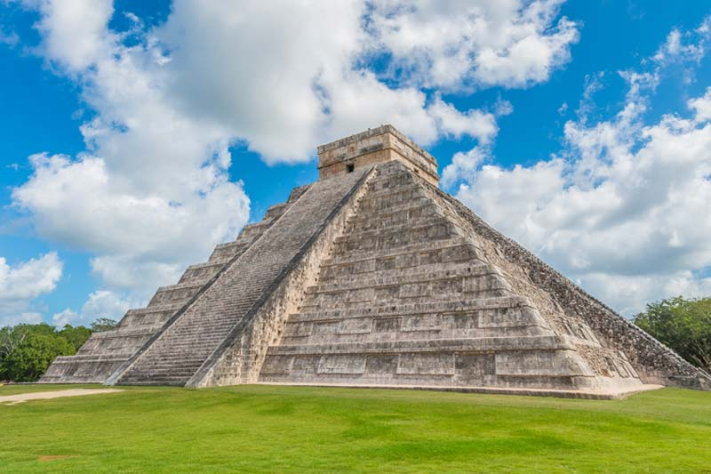

The town of Chichen-Itza was established during the Classic period close to two natural cavities (cenotes or chenes), which gave the town its name "At the edge of the well of the Itzaes". The cenotes facilitated tapping the underground waters of the area. The dates for this settlement vary according to subsequent local accounts: one manuscript gives 415-35 A.D., while others mention 455 A.D. The town that grew up around the sector known as Chichen Viejo already boasted important monuments of great interest: the Nunnery, the Church, Akab Dzib, Chichan Chob, the Temple of the Panels and the Temple of the Deer. They were constructed between the 6th and the 10th centuries in the characteristic Maya style then popular both in the northern and southern areas of the Puuc hills.

The second settlement of Chichen-Itza, and the most important for historians, corresponded to the migration of Toltec warriors from the Mexican plateau towards the south during the 10th century. According to the most common version, the King of Tula, Ce Acatl Topiltzin Quetzalcoatl, or Kukulkan as the Maya translated the name, reportedly took the city between 967 A.D. and 987 A.D.

Following the conquest of Yucatán a new style blending the Maya and Toltec traditions developed, symbolizing the phenomenon of acculturation. Chichen-Itza is a clear illustration of this fusion. Specific examples are, in the group of buildings to the south, the Caracol, a circular stellar observatory whose spiral staircase accounts for its name, and, to the north, El Castillo (also known as the Temple of Kukulkan). Surrounding El Castillo are terraces where the major monumental complexes were built: on the north-west are the Great Ball Court, Tzompantli or the Skull Wall, the temple known as the Jaguar Temple, and the House of Eagles; on the north-east are the Temple of the Warriors, the Group of the Thousand Columns, the Market and the Great Ball Court; on the south-west is the Tomb of the High Priest.

After the 13th century no major monuments seem to have been constructed at Chichen-Itza and the city rapidly declined after around 1440 A.D. The ruins were not excavated until 1841 A.D.

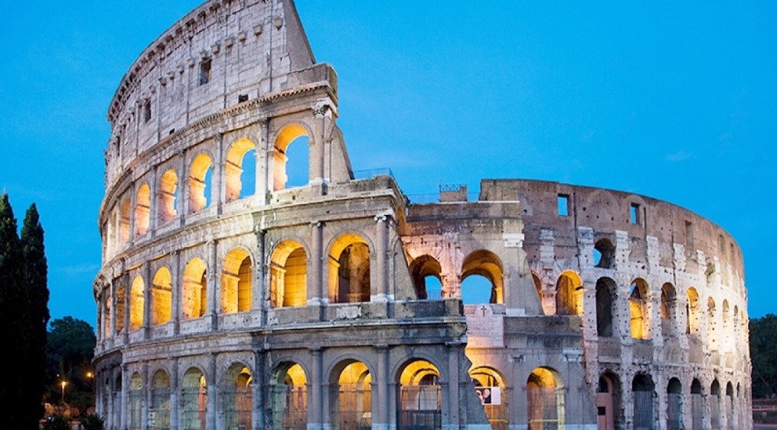6) colosseum - italy

The Roman Colosseum has a long and rich history. From the times when it was used as a gladiatorial arena and witnessed staged hunts with thousands of wild beasts to today, it has seen the Roman Empire rise to its greatest splendor… and dwindle and disappear. It is said that up to 400,000 people met their end on the sands of the arena, as did one million wild animals of many different species.

* **72 AD** – Construction of the Flavian Amphitheater begins under Emperor Vespasian. Vespasian viewed the Colosseum as a gift to the people of Rome — who were unhappy after the disastrous reign of Emperor Nero.
* **80 AD** – Titus, Vespasian’s son, officially dedicates the Amphitheater, also known as the Colosseum, and decrees 100 days of games for its inauguration. Construction would be finalized completely under Titus’s younger brother and successor Domitian in 83 AD.
* **217** – A fire damages the building, destroying its wooden upper level completely.
* **Mid 5th century** – No exact date is known, but the last reports of gladiatorial combat in the Colosseum date from this period, although it continued to be used for hunts of wild beasts for some time afterwards.
* **Late 6th century** – The Colosseum is no longer used as an amphitheater to entertain the citizenry of Rome. Around this time a chapel is affixed to the building, the arena floor is used as a cemetery, and the vaulted spaces that make up the building’s walls under its seats are used as houses and workshops.
* **12th century** – The Frangipani family, a powerful Roman patrician clan of the time, took over the building and converted it into a fortified castle.
* **1349** – The building is seriously damaged in an earthquake, and an entire section of its outer walls collapses. The damage, in the form of lacking parts of the structure, can still be seen today.
* **14th to 18th century** – The Colosseum undergoes progressive degradation as its building materials are stripped to be used elsewhere in Rome. The iron clamps that held the stones together are taken to be melted and reused, and the stone of its structure is scavenged and used to build other buildings throughout the city. Some of the marble that decorated its façade was used in the construction of Saint Peter’s Basilica.
* **1749** – Finally, a bit of good fortune: After centuries of decay, Pope Benedict XIV consecrates the building and declares it must be protected, on the belief that the blood of Christian martyrs spilled in the arena made it a holy place. However, there is little historical evidence to support this claim.
* **19th and 20th centuries** – The Colosseum undergoes successive restoration projects at the instance of various Popes, governments, and the city of Rome.
* **2013 to 2016** – The Colosseum undergoes a major restoration project. The entire façade of the building is cleaned, removing grime and soot accumulated from decades of Roman traffic.
* **Today** – The Colosseum receives over 4 million visitors a year. It is the most visited tourist attraction in Italy and one of the most popular and iconic buildings in the world. From the date of its completion in 80 AD, when it was still known as the Flavian Amphitheater, it is one thousand nine hundred and thirty-seven years old, making it one of the oldest and best preserved human-made structures in the world

**7)** Taj Mahal - India.

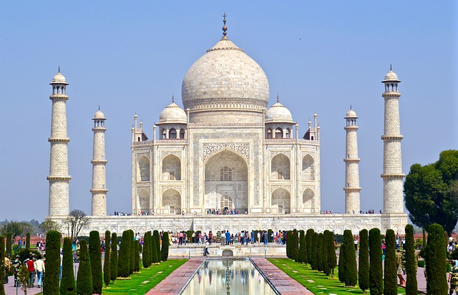

An immense mausoleum of white marble, built in Agra between 1631 and 1648 by order of the Mughal emperor Shah Jahan in memory of his favourite wife, the Taj Mahal is the jewel of Muslim art in India and one of the universally admired masterpieces of the world's heritage

The Taj Mahal is located on the right bank of the Yamuna River in a vast Mughal garden that encompasses nearly 17 hectares, in the Agra District in Uttar Pradesh. It was built by Mughal Emperor Shah Jahan in memory of his wife Mumtaz Mahal with construction starting in 1632 AD and completed in 1648 AD, with the mosque, the guest house and the main gateway on the south, the outer courtyard and its cloisters were added subsequently and completed in 1653 AD. The existence of several historical and Quaranic inscriptions in Arabic script have facilitated setting the chronology of Taj Mahal. For its construction, masons, stone-cutters, inlayers, carvers, painters, calligraphers, dome builders and other artisans were requisitioned from the whole of the empire and also from the Central Asia and Iran. Ustad-Ahmad Lahori was the main architect of the Taj Mahal.